THE LIVING ENVIRONMENT

Living organisms can affect others, either helping or harming them. They can also affect the physical environment they live in.

Habitats

• Place where an organism lives.
• Has all of its requirements to survive.
• Habitat is not the same as environment - environment discusses all the factors that affect the
organism; habitat is simply where it lives.

e.g. Grey kangaroo lives in Southwest WA, South Australia and parts of Victoria.

Ecosystems

• Any place where the organisms and their physical surroundings form an environment
different to others nearby.
• They can be large or small in size.

e.g. Large lake compared to a small pond or billabong.

• There are 3 parts of an ecosystem.

• Living organisms.
• Physical surroundings.
• The living and non-living factors that make up the environment.

Communities

• Made up of all the living organisms in an ecosystem at a particular time.
• Can be hundreds or thousands of different types of organisms.
• Population - the number of a particular organism found in the community.

e.g. A lake ecosystem may contain hundreds of thousand of tadpoles.

How Organisms Affect Each Other

• Competition - occurs when different organisms need the same resource and there is a limited
amount.

e.g. Grass and a tree compete for light - the grass does not grow very well in the shade of the
tree.

Territories are established by animals to ensure animals have enough food, shelter,
water and nesting sites. They defend these areas from intruders.

• Predation - one organism eats another.

e.g. Owl (predator) feeds on mice (prey).

• Mutualism - relationship where two organisms live closely together to help each other.

e.g Sheep have micro-organisms in their gut to digest cell walls in the plant material they
eat. The sheep survives, as do the organisms.

Flowers are pollinated by insects and birds. The flowers produce seeds and the animals
receive pollen or nectar as food.

• Parasitism - an organism lives in or on another, causing harm to the host organism.

e.g. Tapeworms live in the human intestine, absorbing food to grow but making the human
sick.

Ticks and fleas feed on the blood of animals by burrowing into their skin.

• Commensalism - relationship where one organism benefits and the other is unharmed.

e.g. Remora fish stick to sharks and feed on the scraps left by the shark when it feeds. The
shark is unaware of the fish and is unharmed.

How Organisms Affect The Physical Environment

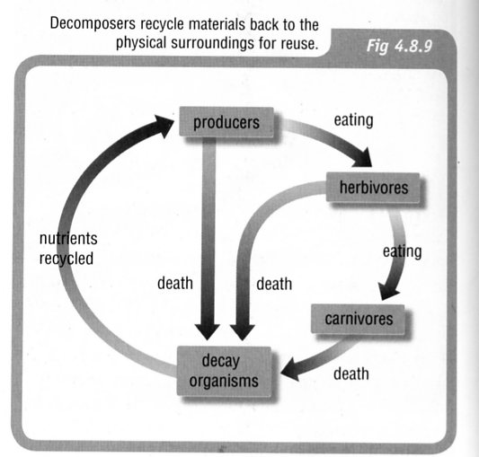
Recycling Nutrients

• Bacteria break down dead organisms and wastes - they are
called decomposers.
• This releases nutrients back into the soil for plants.
• The nutrients have been recycled.

• CO₂ is produced by all living things during respiration and
is recycled into O₂ by plants during photosynthesis.

• Elements such as carbon, oxygen, hydrogen, nitrogen and
sulphur are recycled in nature - this is the role of the
decomposers.

(See notes on Cycles in Nature)

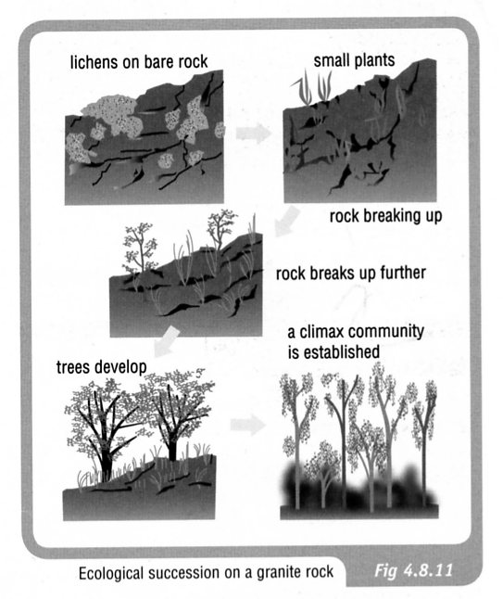
Ecological Succession

• Term used for the changing communities formed in an
area over a period of the time.
• Colonisation of bare rock by lichen - called a pioneer
plant as it is the first to grow there.
• They break the rock down to form soil.
• Small plants then grow in the soil.
• More elaborate communities then form over a long period
of time.

Cycles In Nature

Carbon Cycle

The element carbon is one of the main materials in sugars, proteins and fats - these are found in the tissues of all living things. Carbon is also found in vitamins, as well as in waste products such as CO₂ and urea.

In the carbon cycle, plants convert CO₂ to food and O₂ during photosynthesis.

Animals (and plants at night) produce CO₂ during respiration.

On decomposition, all plant and animal material is reduced to CO₂ by the decomposers, and the residual nutrients are returned to the soil.

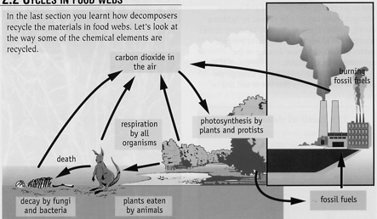

Nitrogen Cycle

Nitrogen makes up 78% of the atmosphere, is found combined with oxygen as nitrates in the soil, and is one of the elements found in proteins (these are the building blocks of cells and tissues).

Animals obtain their nitrogen either from plants or other animals.

Plants get their nitrogen from the nitrates in the soil. They are soluble in water and are easily absorbed by plant roots.

Nitrates can be formed in the following ways.

• The decay of dead organisms by decomposers.

• Atmospheric nitrogen changed by nitrogen-fixing bacteria in the soil and
in nodules on the roots of legumes such as clover, peas and beans.

• Lightning causes atmospheric nitrogen N₂ to react with O₂ to form oxides
of nitrogen. These form nitrates when they dissolve into water.

